# INTERFACE

## Introduction

System design is the solution to the creation of a new system. This phase is composed of several systems. This phase focuses on the detailed implementation of the feasible system. It emphasis on translating design specifications to performance specification is system design. System design has two phases of development logical and physical design.

During logical design phase the analyst describes inputs (sources), outputs (destinations), databases (data stores) and procedures (data flows) all in a format that meats the uses requirements. The analyst also specifies the user needs and at a level that virtually determines the information flow into and out of the system and the data resources. Here the logical design is done through data flow diagrams and database design.

The physical design is followed by physical design or coding. Physical design produces the working system by defining the design specifications, which tell the developer exactly what the candidate system must do.

The developer writes the necessary programs that accept input from the user, perform necessary processing on accepted data through call and produce the required report on a hard copy or display it on the screen.

# Graphics Design

Graphic design, also known as communication design, is the art and practice of planning and projecting ideas and experiences with visual and textual content. The form it takes can be physical or virtual and can include images, words, or graphics. The experience can take place in an instant or over a long period of time. The work can happen at any scale, from the design of a single postage stamp to a national postal signage system. It can be intended for a small number of people, such as a one-off or limited-edition book or exhibition design, or can be seen by millions, as with the interlinked digital and physical content of an international news organization. It can also be for any purpose, whether commercial, educational, cultural, or political.

* **Ahref Graphic Arts**



**Fig. 3.1.1 Ahref Brand Logo**

A logo is a graphic mark, emblem, symbol or stylized name used to identify a company, organization, product or brand.



**Fig. 3.1.2 Ahref Admin Logo**

Here Admin Logo is from the same brand, just to distinguish normal user and Admin.

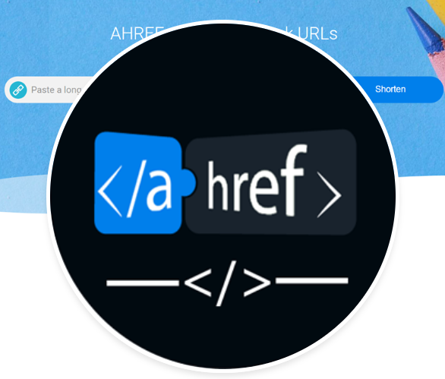

**Fig. 3.1.3 FB Brand Profile Logo**

Profile picture and cover photo can be seen by anyone visiting your Fb page. It should be same to recognize your bran from far away

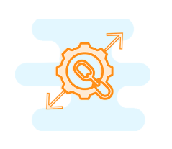

### Fig. 3.1.4 Domain Expander

Expand your short link and see what's its original domain.



**Fig. 3.1.5 Geotarget**

Geotarget your links to redirect visitors to specialized pages and increase your click conversion.

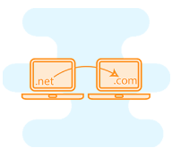

### Fig. 3.1.6 Domain Changer

Mask your links so that nobody finds what’s inside it.

# Directory Listing and folder Structure

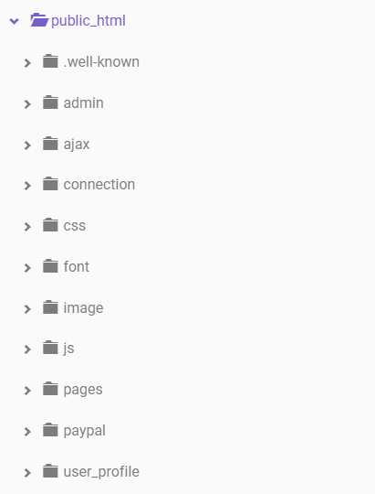

### Fig. 3.2.1 Directory listing

Directorylisting is a web server function that displays a list of all the files when there is not

an index file, such as index.php and default.asp in a specific website directory**.**

# 3.3 User Interface Design of Ahref web App

User Interface Design means the design of application with which the user interacts. So it should be kept in mind that UI should be very simple and easy to use. It should be simple enough in look and feel also.



### Fig. 3.3.1 Navigation Bar

A navigation bar is a link to appropriate sections/pages in a website that helps readers in

traversing the online document. Considered a traditional method of navigation, a navigation can be implemented in a number of ways, namely, horizontally or vertically, or fixed or dynamic. A navigation bar implementation is considered one of the key points of Web design and usability.

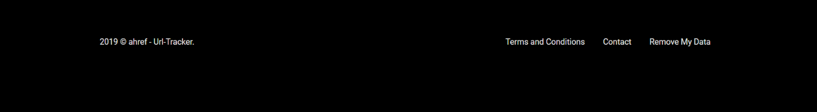

### Fig. 3.3.2-Footer

In general, a footer is an area at the bottom of a document page that contains data common to

other pages. The information in footers, which includes things like such as page numbers,

creation dates, [copyrights](https://www.computerhope.com/jargon/c/copyrigh.htm), or references, can be changed all of the pages in a document at the

same time.

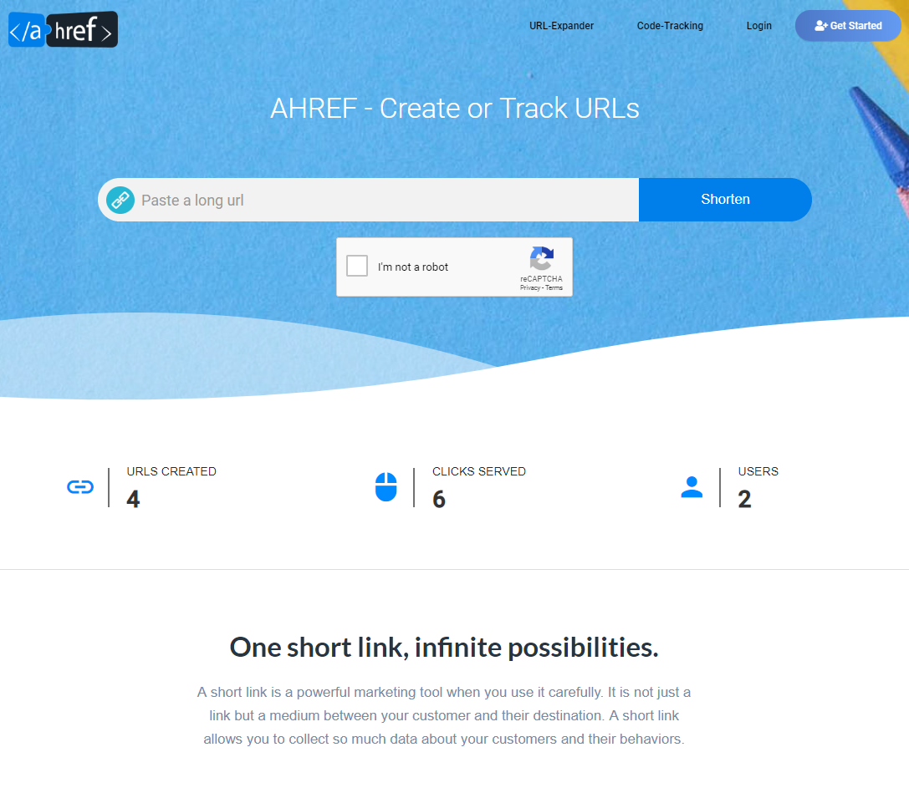

**Fig. 3.3.3 Landing Page**

Ahref index page often called as landing page. This is first page will open when user request for ahref.tech

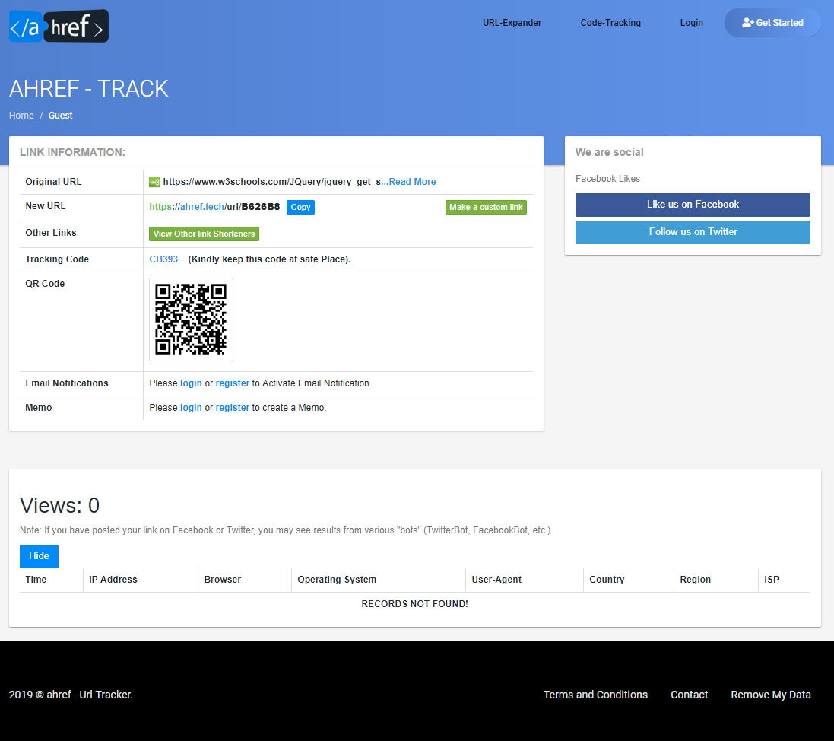

**Fig. 3.3.4 Track Page**

Once the user enters the desire long URL in the landing text field then that user be considered as Guest user because he is not created an account yet and that’s why it the web app works as Guest for the instance. Now user will be redirected to the Track page where user can manage all the activities associated with the long URL.

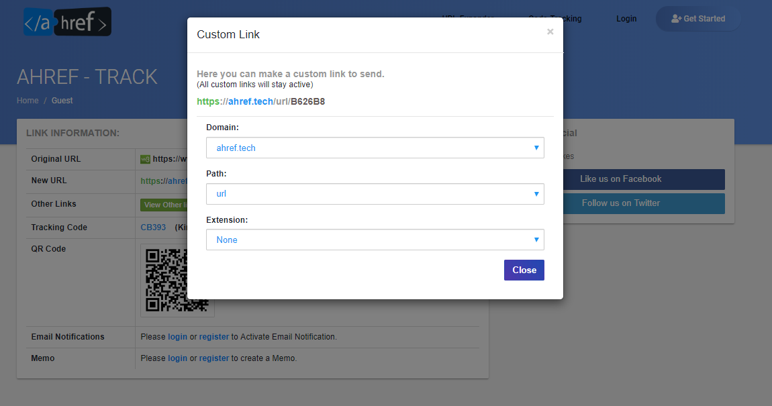

**Fig. 3.3.5 Track Page (custom link generation)**

Once the long URL is successfully generated into short code now user have ability to customize their default short URL into custom made URL link

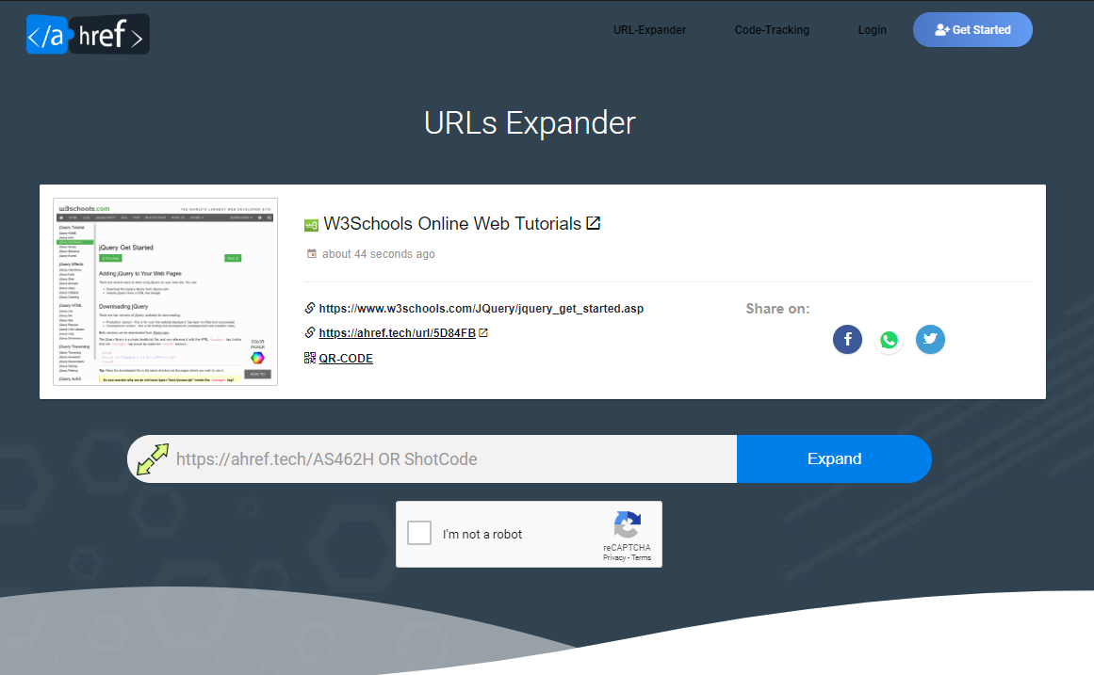

**Fig. 3.3.6 URL Expander**

URL Expander that unshortens / deshortens any URL to a long URL masked by any URL-

Shortener. Once you got the shorten code you can enter the shorten link inside the

text field or just the code to make it unshorten.

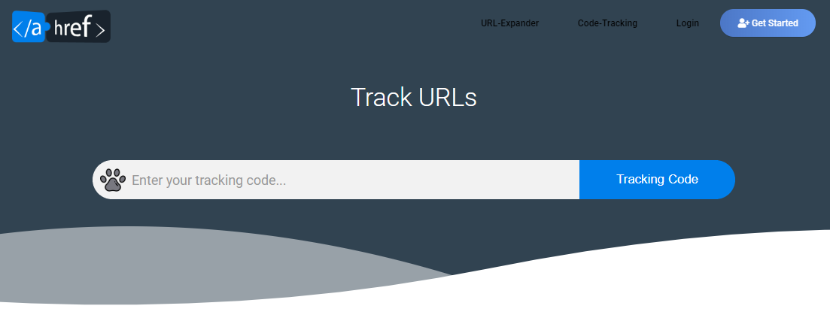

**Fig. 3.3.6 Code Tracker**

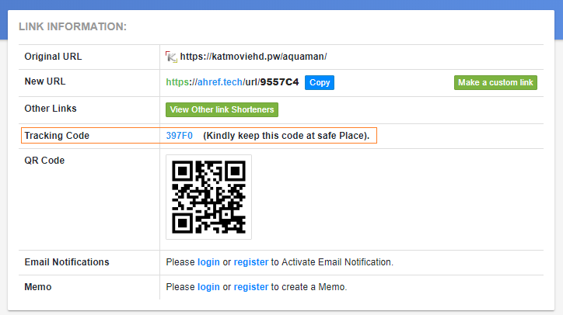

Code tracker page will constantly help Guest or registered user to track and manage URL

activity. User or visitor need to have a Tracking code in order to access the track page in

future. Tracking code can be easily found in User dashboard along with particular naming URL conventions.

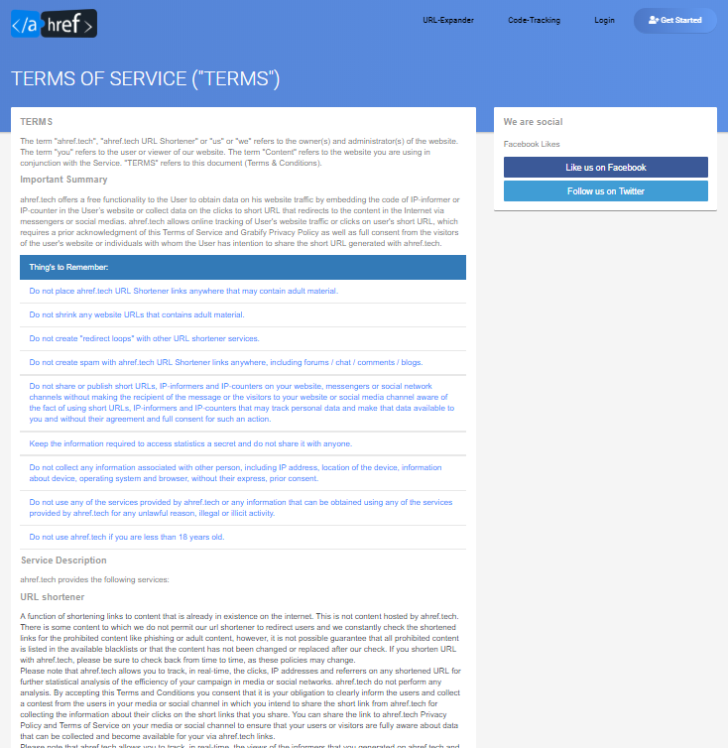

**Fig. 3.3.7 Terms and Conditions**

Terms of service (also known as terms of use and terms and conditions, commonly abbreviated as TOS or ToS, ToU or T&C) are rules by which one must agree to abide in order to use a service. Terms of service can also be merely a disclaimer, especially regarding the use of websites.

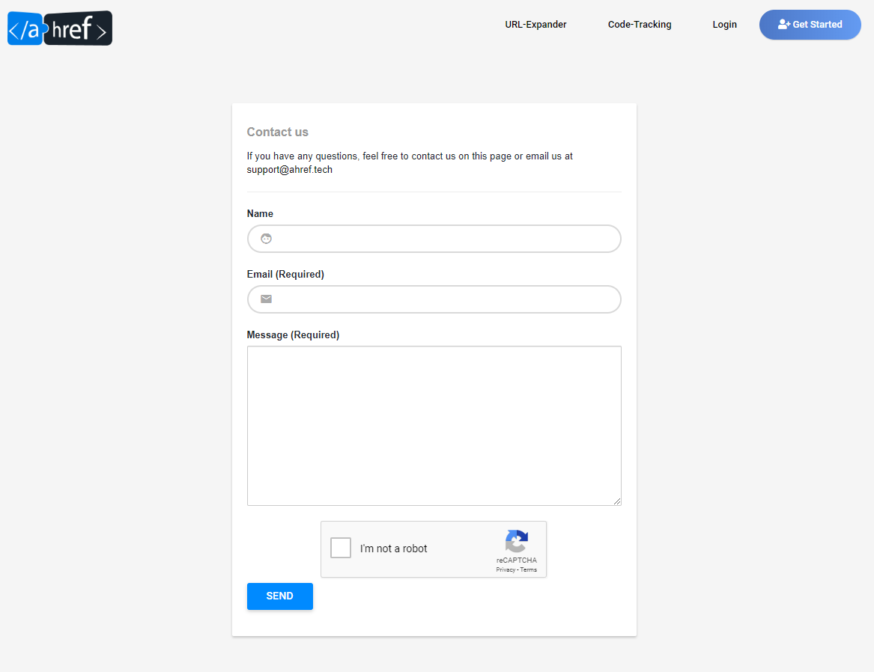

**Fig. 3.3.8 Contact Us**

An individual's private or personal information by which another person, business, or entity can use to reach the individual. For example, a company database may have its employees' private and public contact information for purposes of reaching an employee for various reasons. This can also be used to indicate a person. For example, an individual may say that he or she has a contact at XYZ Company, meaning the knows a person at XYZ Company and hasa way of reaching this person.

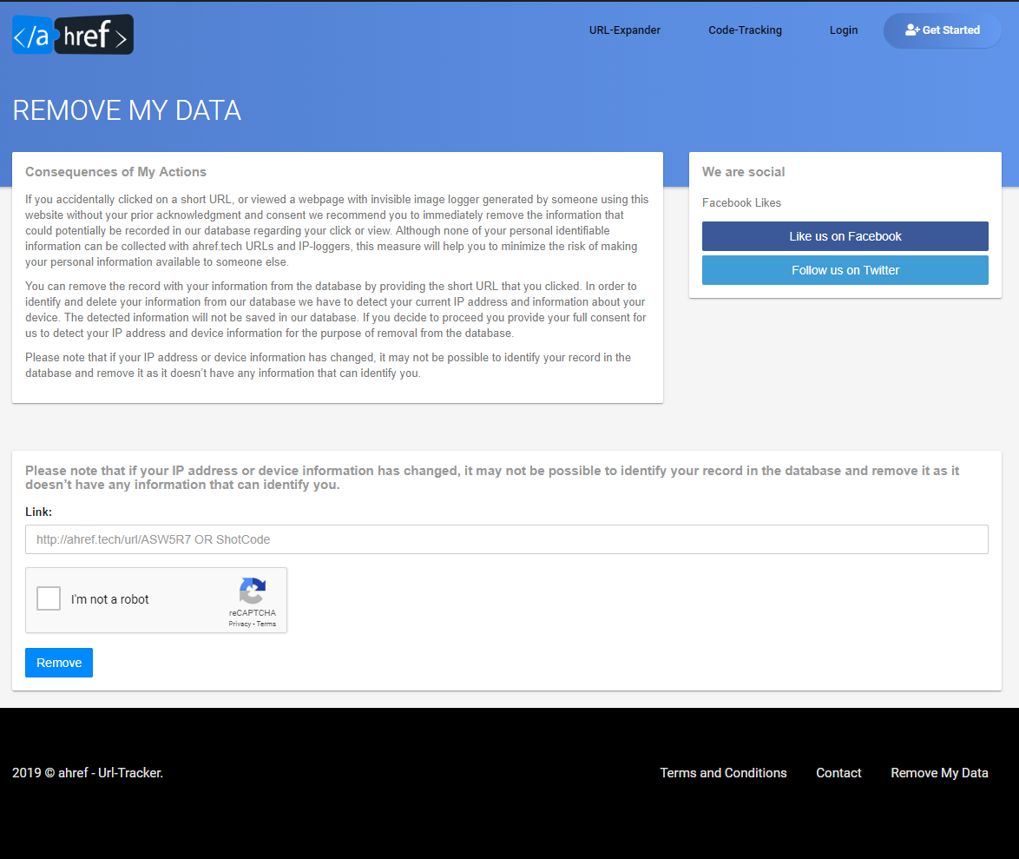

**Fig. 3.3.9 Remove DATA**

If somehow user accidently click on the short link and the personal info is capture in the database then user have a ability to delete his data on the from the db. note that if user IP address or device information has changed, it may not be possible to identify user record in the database and remove it as it doesn’t have any information that can identify you.

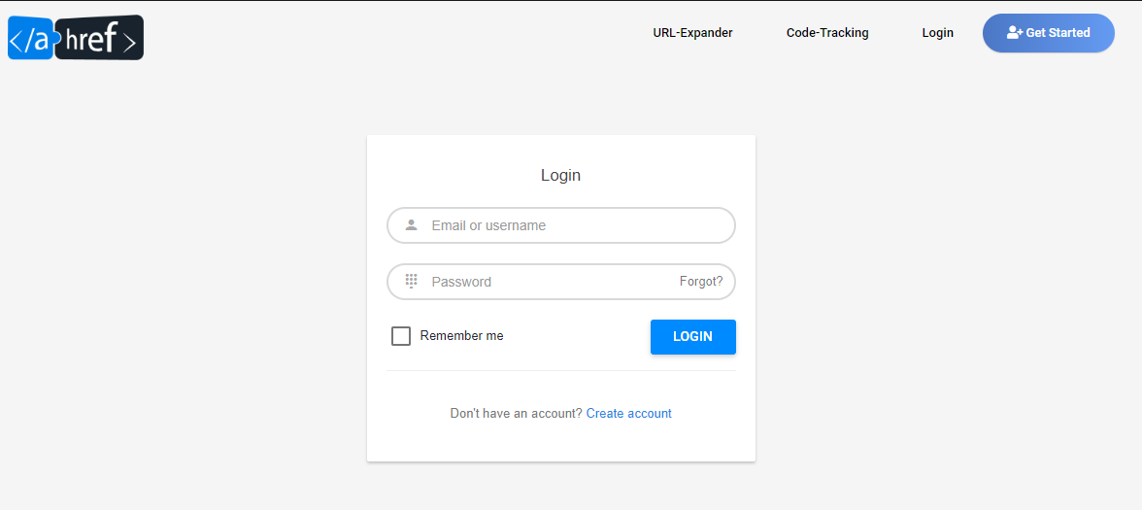

**Fig. 3.3.1.0 Login Page**

A login, logging in or logging on is the entering of identifier information into a system by a user in order to access that system (e.g., a computer or a website).A login generally requires the user to enter two pieces of information, first a user name and then a password. Once user enters correct Credentials then user can able to access the user dashboard.

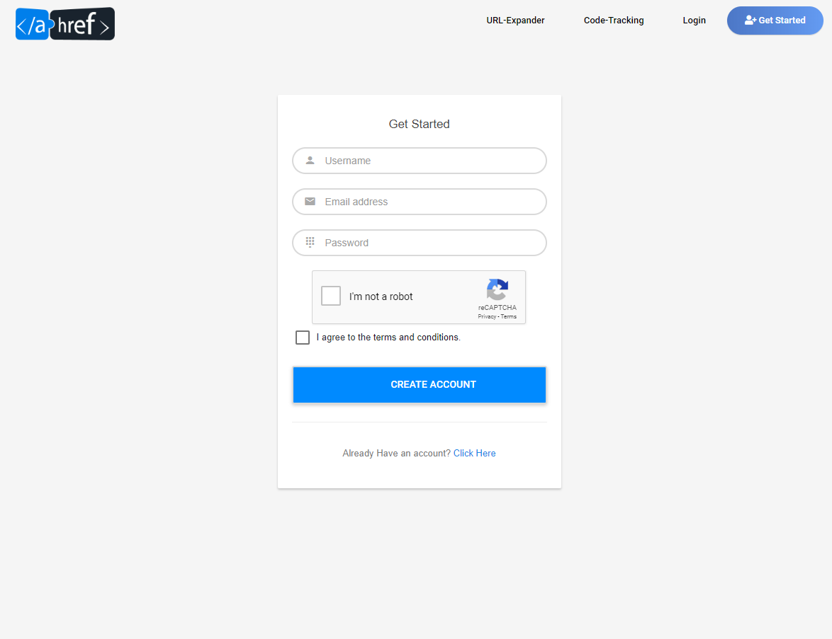

**Fig. 3.3.1.1 Signup Page**

A registered user is a [user](https://en.wikipedia.org/wiki/User_(system)) of a [website](https://en.wikipedia.org/wiki/Website), [program](https://en.wikipedia.org/wiki/Computer_program), or other system who has previously registered. Registered users normally provide some sort of [credentials](https://en.wikipedia.org/wiki/Credential)(such as a username or e-mail address, and a password) to the system in order to prove their identity: this is known as [logging in](https://en.wikipedia.org/wiki/Login). Systems intended for use by the general public often allow any user to register simply by selecting a *register* or *sign up* function and providing these credentials for the first time. Registered users may be granted privileges beyond those granted to unregistered users.

# 3.4 User Interface Design of User Dashboard

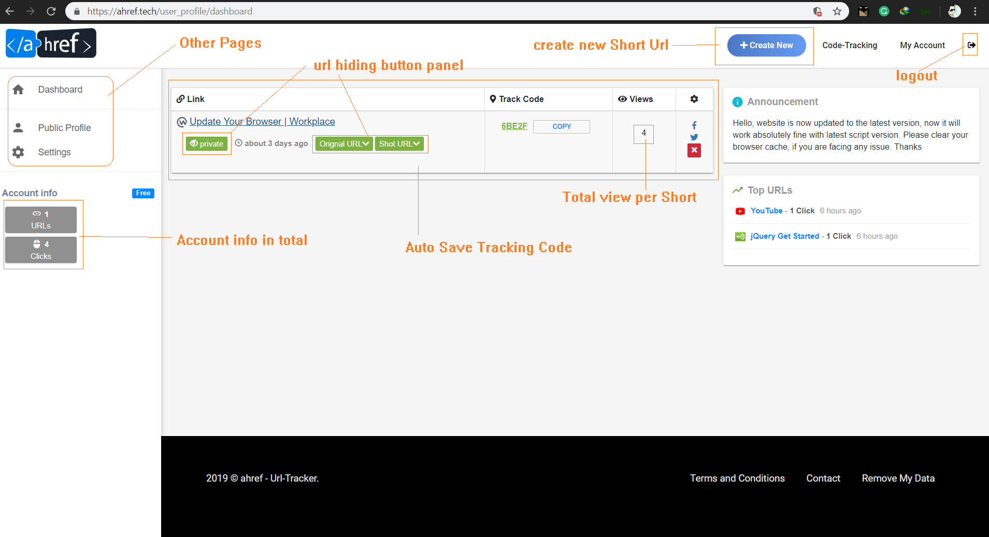

**Fig. 3.4.1 User Dashboard**

In information technology, a dashboard is a user interface that, somewhat resembling an automobile's dashboard, organizes and presents information in a way that is easy to read. However, a computer dashboard is more likely to be interactive than an automobile dashboard (unless it is also computer-based). To some extent, most graphical user interfaces ([GUI](https://searchwindevelopment.techtarget.com/definition/GUI)s) resemble a dashboard. However, some product developers consciously employ this metaphor (and sometimes the term) so that the user instantly recognizes the similarity. Once user is logged in now all the short code that he will create gonna save in its dashboard. This will help user to keep track its shotners.

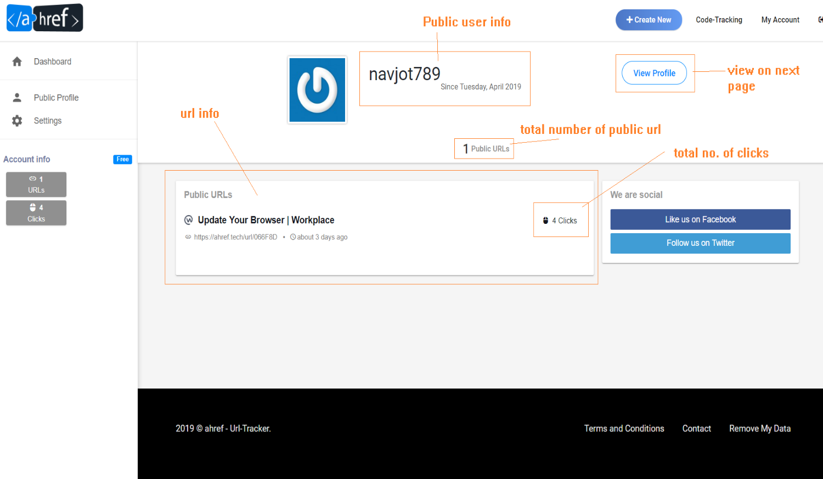

**Fig. 3.4.2 User Public profile**

Public profile gives user ability to show publicly there all the short URL that he

Created so long, user can manage these links by going in user dashboard and by enabling 7 disabling public/private button.

User public profile can be access by User **Username**:

**Example**:

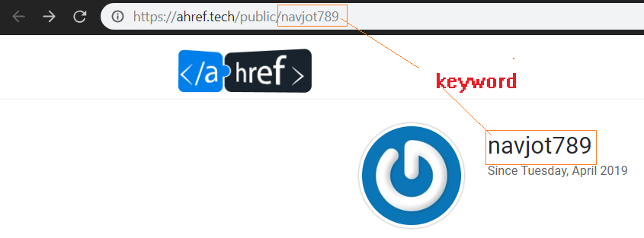

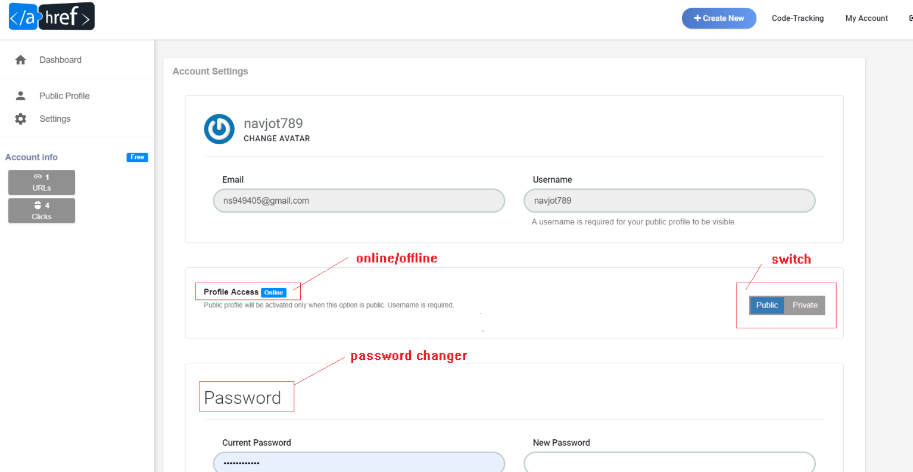

**Fig. 3.4.3 User Dashboard Account Settings**

Here user can be able to change the account setting according to its convenient

Public profile switch help user to on/off the public profile visibility. Password change helps the User to quickly change its password but user must be knowing the old account password in order to change password.

# 3.5 User Interface Design of Admin Dashboard

Administrators use specialized software to store and organize data of user.

The role may include [capacity planning](https://en.wikipedia.org/wiki/Capacity_planning), [installation](https://en.wikipedia.org/wiki/Installation_(computer_programs)), [configuration](https://en.wikipedia.org/wiki/Computer_configuration), [database design](https://en.wikipedia.org/wiki/Database_design), [migration](https://en.wikipedia.org/wiki/Data_migration), performance monitoring, [security](https://en.wikipedia.org/wiki/Computer_security), [troubleshooting](https://en.wikipedia.org/wiki/Troubleshooting), as well as [backup](https://en.wikipedia.org/wiki/Backup) and [data recovery](https://en.wikipedia.org/wiki/Data_recovery)

Ahref Administrator can be access using below link:



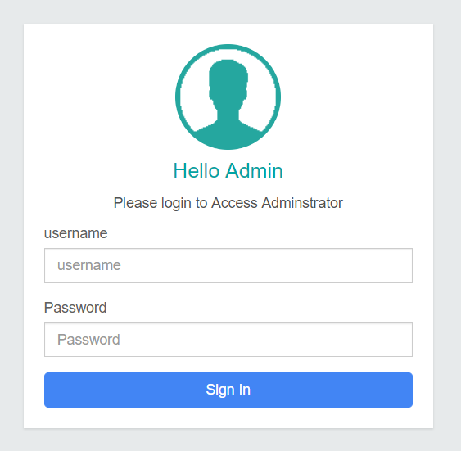

**Fig. 3.5.1 Admin Login Panel**

By entering Admin Credentials, you will be able to access the admin dashboard.

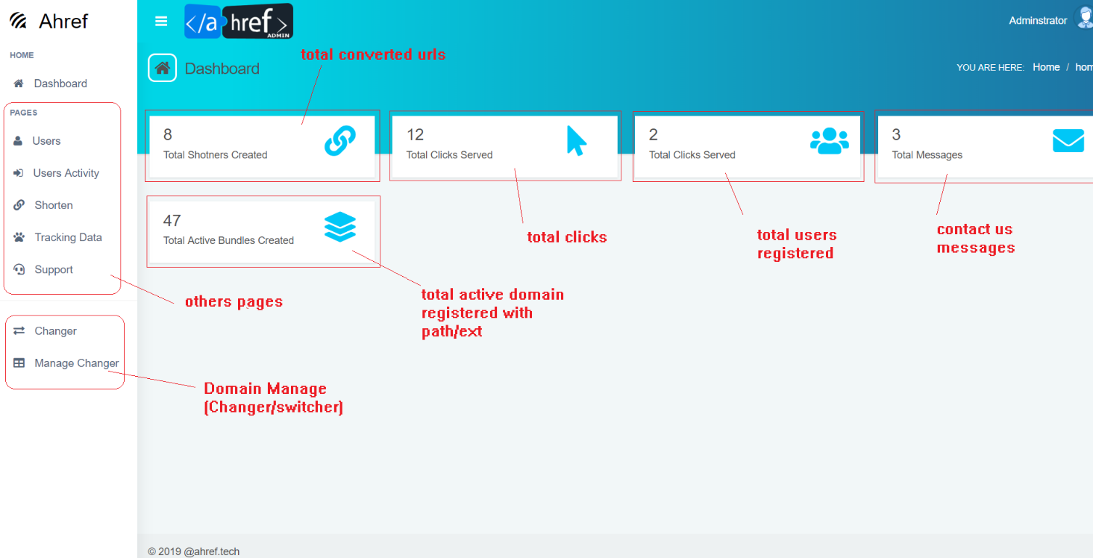

**Fig. 3.5.2 Admin Dashboard**

Once the login credentials are entered then the first page visible will be dashboard

This page contains all the statics records of data. Admin has permission to add delete update Records in the database. All change will reflect directly to the user profile in real time.

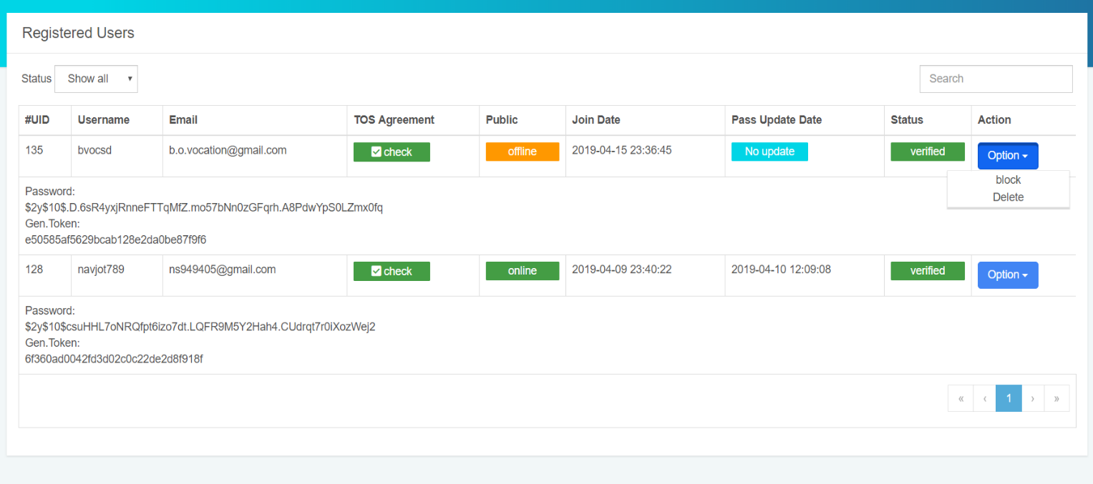

**Fig. 3.5.3 Admin User Dashboard**

Once the user is registered and Activate his profile by going to his personal email ID this

process act as a proof here that the user is Valid. All the registered user will be visible here.

Admin has Authority to delete any user data and suspend any user as well. The password

& token wasn’t be in plain text due to security reasons. Token is generated at the time once the user is successfully activating his profile by the link that sent to his email ID. Link is valid for 4hr else link will be expire.

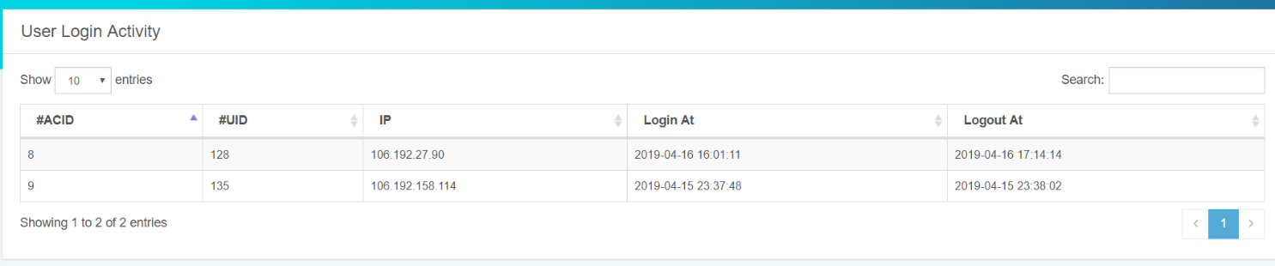

**Fig. 3.5.4 User (Login History)**

Once the user is login to user dashboard the timestamp is started and its login activity is noted. Same as for logout. This is done due to security reasons.

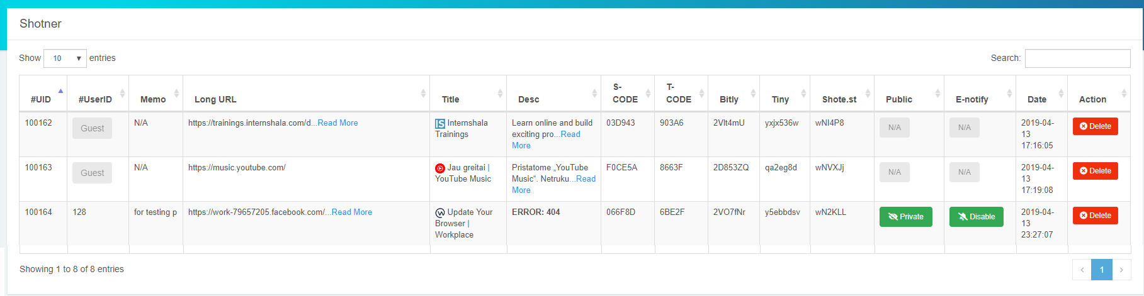

**Fig. 3.5.5 Shotners**

All the shotners that are created so far will be noted in the shotners Activity. Whether it’s a guest user or Account holder it doesn’t matter. It’s a main hub for all shotners, Admin have privileges to private/public private and disable email notification, delete on any shotner

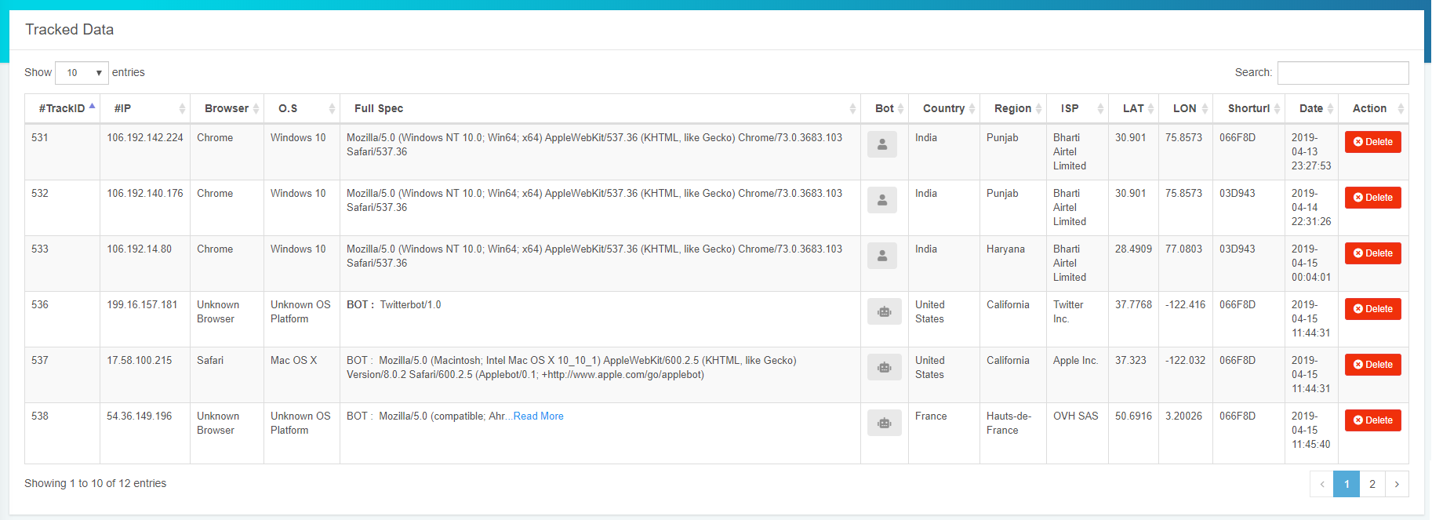

**Fig. 3.5.6 Tracking Data**

Once the Short link is generated and spread on any platform, anybody that clicked on the link its details will be captured and uploaded to the backend. Here Admin has privilege that the data can be modified or deleted. Also, normal user and bot are distinguishing with the help of font awesome icon

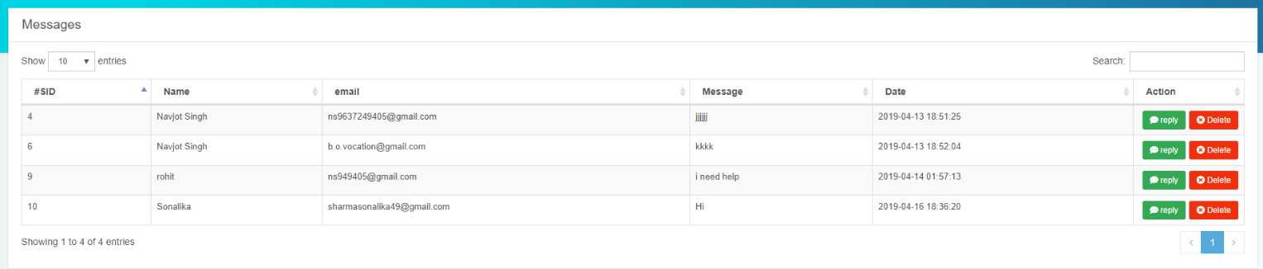

**Fig. 3.5.7 Support Messages**

If in future if any user facing issue regard his account or any other query that he has, will be deliver to the messages table. All records being captured here. Admin has privilege to delete or replay back in order to communicate with the user.

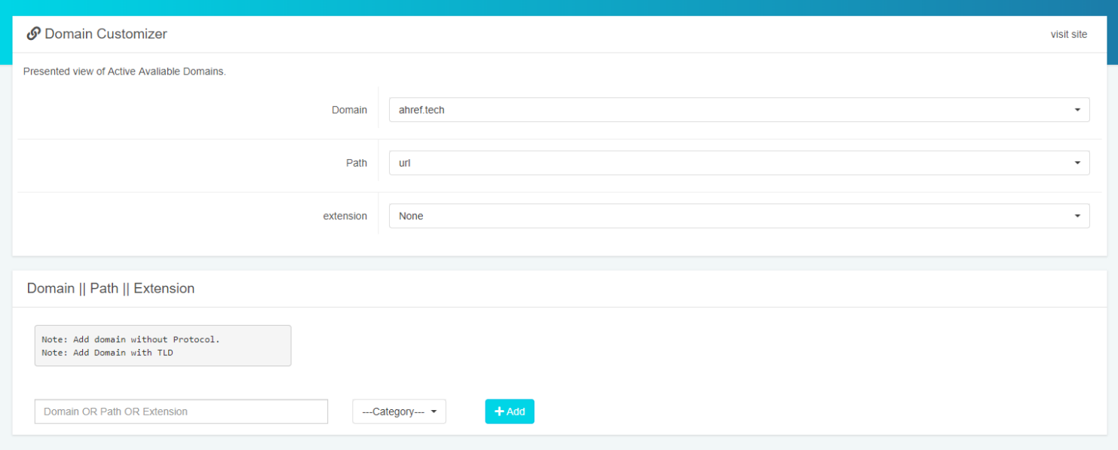

**Fig. 3.5.8 Domain Customizer**

Admin can add new **domain + path + extension** and all change would be reflected in above select tags

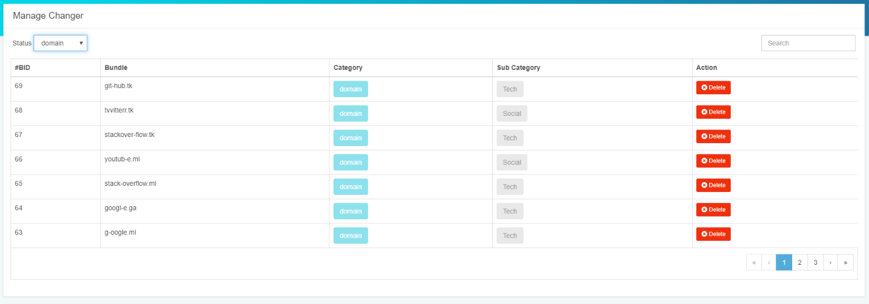

**Fig. 3.5.9 Manage Changer**

All the newly addeddomain + path + extensionis store in the Manage changer page

# 3.6 Database Design

Database design is the process of producing a detailed data model of a database. This logical data model contains all the needed logical and physical design choices and physical storage parameters needed to generate a design in a data definition language, which can then be used to create a database. A fully attributed data model contains detailed attributes for each entity.

The term database design can be used to describe many different parts of the design of an overall database system. Principally, and most correctly, it can be thought of as the logical design of the base data structures used to store the data. In the relational model these are the tables and views. In an object database the entities and relationships map directly to object classes and named relationships. However, the term database design could also be used to apply to the overall process of designing, not just the base data structures, but also the forms and queries used as part of the overall database application within the database management system (DBMS).

The process of doing database design generally consists of a number of steps which will be carried out by the database designer. Usually, the designer must:

* Determine the relationships between the different data elements.
* Superimpose a logical structure upon the data on the basis of these relationships.

## Design process

* Determine the purpose of the database - This helps prepare for the remaining steps.
* Find and organize the information required - Gather all of the types of information to record in the database, such as product name and order number.
* Divide the information into tables - Divide information items into major entities or subjects, such as Products or Orders. Each subject then becomes a table.
* Turn information items into columns - Decide what information needs to be stored in each table.
* Each item becomes a field, and is displayed as a column in the table. For example, an Employees table might include fields such as Last Name and Hire Date.
* Specify primary keys - Choose each tables primary key. The primary key is a column, or a set of columns, that is used to uniquely identify each row. An example might be Product ID or Order ID.
* Set up the table relationships - Look at each table and decide how the data in one table is related to the data in other tables. Add fields to tables or create new tables to clarify the relationships, as necessary.

## Overview and interconnection of web Hosting

List of Available Active Domains: Main domain: http://ahref.tech

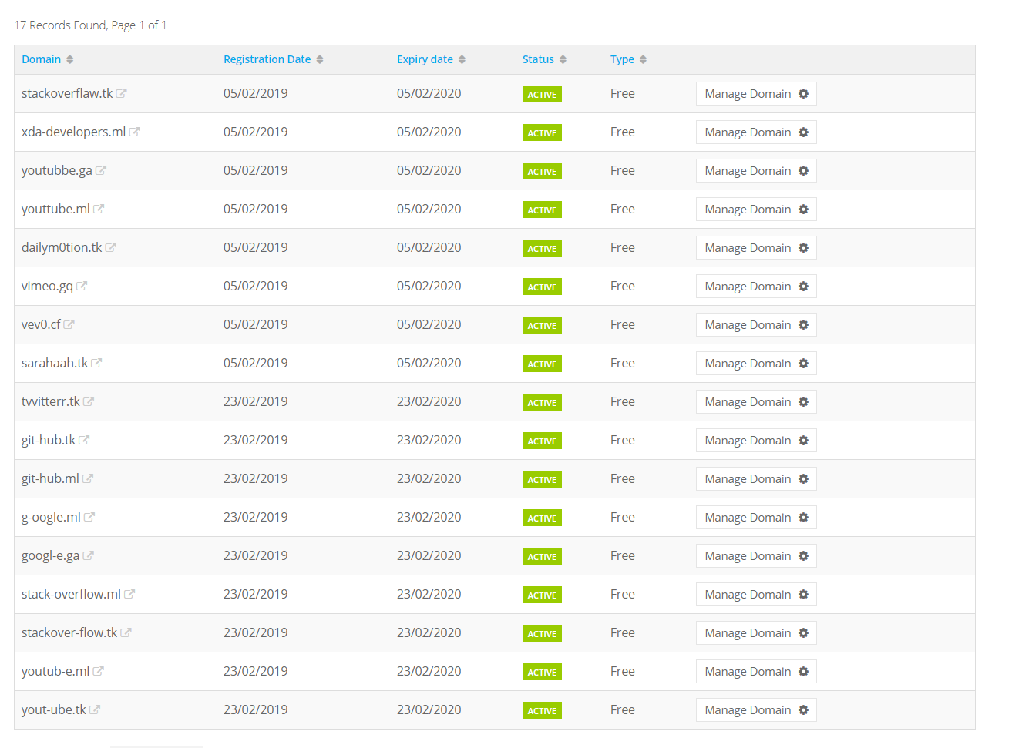

**Fig. 3.6.1 Available connected domains to the hub**

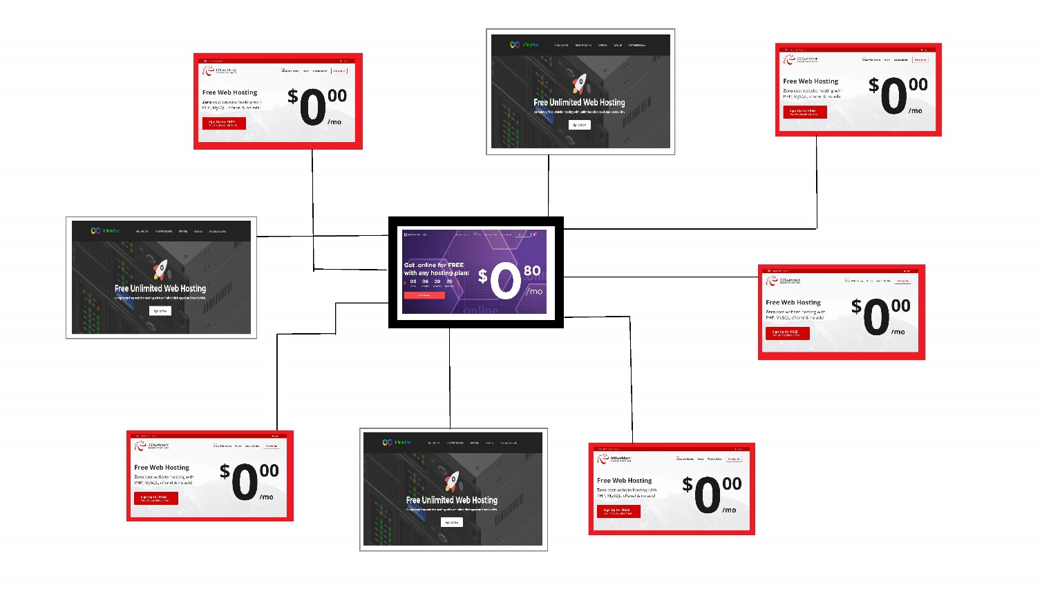

**Fig. 3.6.2 Inter-connection between hosting’s**

Above example represent the relationship between different platform hosting and their interconnections. Here the Origin platform is known as **Hostinger.com** which is the main hub for all interconnected platforms. All the data first travel through **Free** servers and then reaches the Main hosting Hub. Rest of all named as **000webhost, infinityfree**.

* **Hostinger.com** is PAID server
* **000webhost.com** is FREE server
* **Infinityfree.net** is FREE server

## ER Diagrams

An ER diagram is a diagram that helps to design databases in an efficient way. Attributes in ER diagrams are usually modelled as an oval with the name of the attribute, linked to the entity or relationship that contains the attribute.

Within the relational model the final step can generally be broken down into two further steps, that of determining the grouping of information within the system, generally determining what are the basic objects about which information is being stored, and then determining the relationships between these groups of information, or objects.

An Entity Relationship Diagram (ERD) is a visual representation of different data using conventions that describe how these data are related to each other. ER diagrams are most often associated with complex databases that are used in software engineering and IT networks. In particular, ER diagrams are frequently used during the design stage of a development process in order to identify different system elements and their relationships with each other.

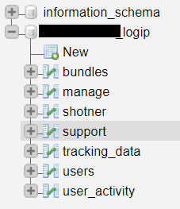

**Fig. 3.6.3 DB structure**

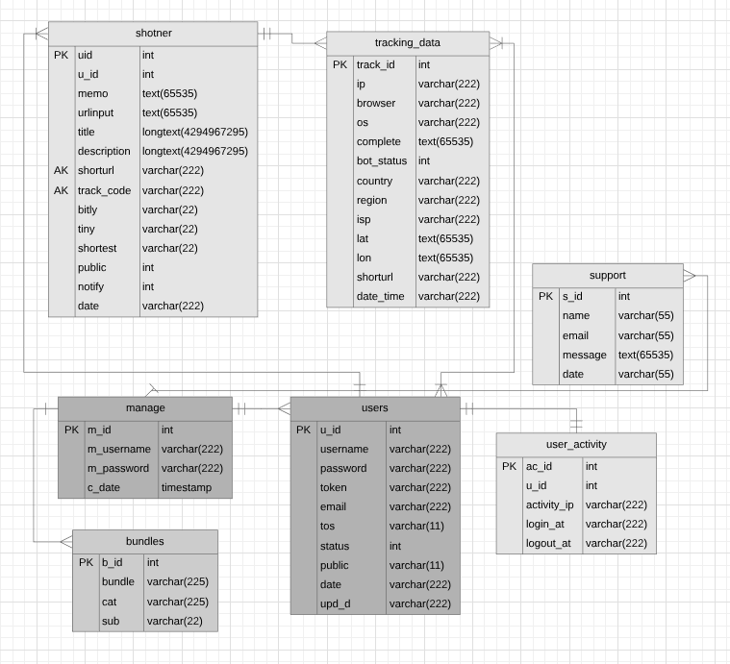

**Fig. 3.6.4 ER diagram of Tables Schema**

To understand the ER Diagram in brief Lets take an example. But first look at the cardinality:

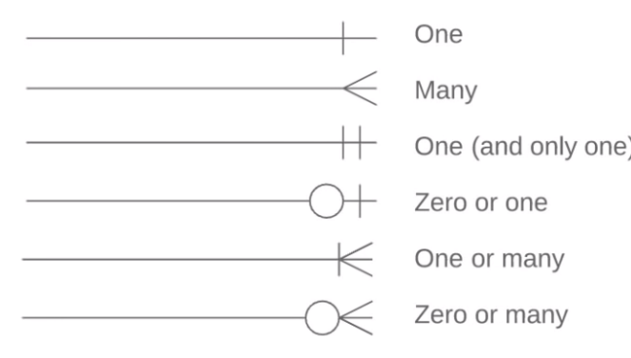

**Fig. 3.6.5 ER diagram cardinality**

* **Entity Relationship between (Tables) Shotner and tracking_data**

Let’s say visitor visit the https://ahref.tech and try to create short URL, Now short code is successfully generated and visitor spread the link to all their friends and now all whom ever click on that link, their device details will be captured and uploaded to the server. So, we can say that:

One Shotner have many entity relationships with tracking_data because on one shorten link many details will be captured. As reverse, only one unique shotner will have my different collection of incoming data.

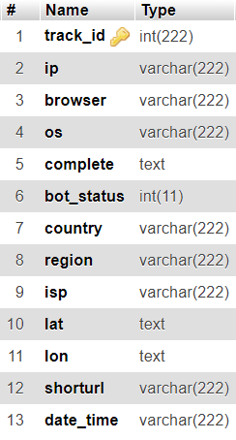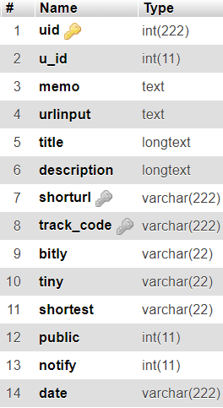

**Fig. 3.6.6 Schema of (Tables) Shotner and tracking_data**

* **Entity Relationship between (Tables) Shotner and users**

**One Registered** user Can easily create **one or more than one** Shotner. Reverse, **one or**

**many** shotners can easily create by **one Registered** user.

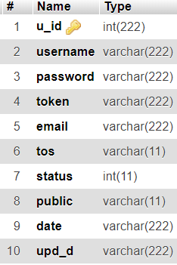

**Fig. 3.6.6 Schema of (Table) Users**

* **Entity Relationship between (Tables) tracking_data and users**

One or many users can click on link to generate tracking data, in reverse one or many

different tracking data can be generated by one or many users.

* **Entity Relationship between (Tables) manage and users**

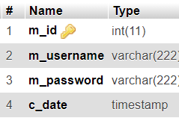One and only one manage(admin) can manage many users, in reverse many users can be handle by only one Admin.

**Fig. 3.6.7 Schema of (Table) manage**

* **Entity Relationship between (Tables) manage and bundles**

One admin can add many bundles(domains), in reverse many bundles can be added by one

Admin.

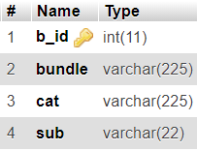

**Fig. 3.6.7 Schema of (Table) Bundles**

* **Entity Relationship between (Tables) manage and support**

Many users can contact with one admin. In reverse one admin can contact many users

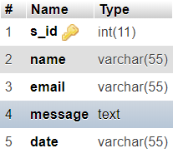

**Fig. 3.6.7 Schema of (Table) support**

* **Entity Relationship between (Tables) users and user_activity**

One and only one user has unique login and logout user_activity, in reverse only and only one unique user_activity assign to one and only one user.

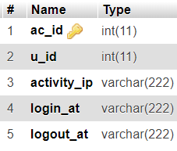

**Fig. 3.6.7 Schema of (Table) user_activity**

## UML Diagrams

* **Use Case Diagram**

The system design can be clearly explained from the following diagrams: Use Case Diagram:

A Use Case diagram at its simplest is a representation of a user’s interaction with the system and depicting the specifications of a use case. A use case diagram can portray the different types of users of a system and the various ways that they interact with the system. This type of diagram is typically used in conjunction with the textual use case and will often be accompanied by other types of diagrams as well.

There are two types of user in this application, user and Guest. Following depicts their use case diagram:

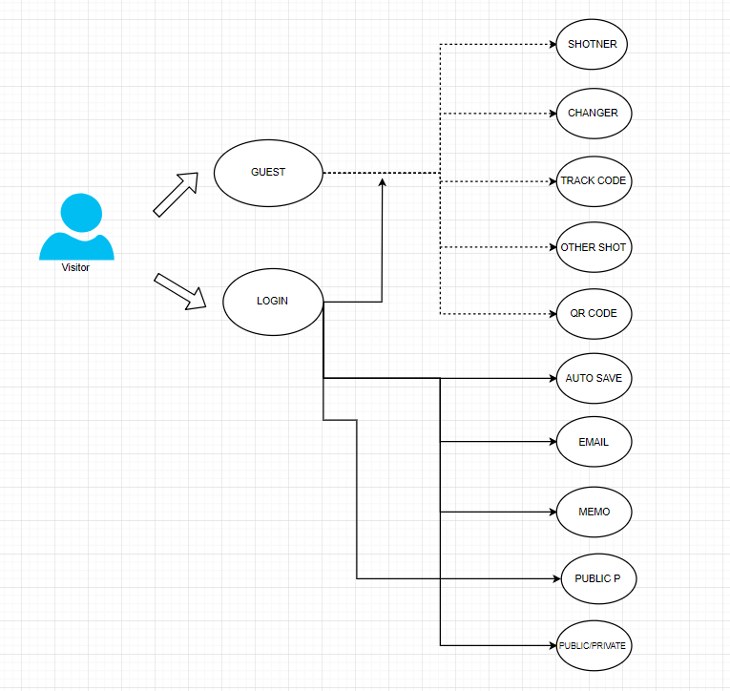

**Fig. 3.6.8 UCD for visitor**